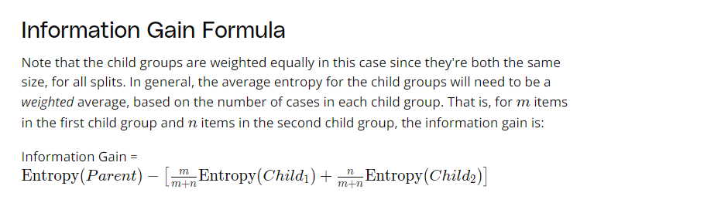

### Quiz Question

Assume we have a dataset with columns Car_Price and Car_Engine_Size and we want to recommend a specific car that is a good recommendation for the 25 age group. You calculate entropy and find that

Splitting by the Car_Price column gave us an information gain of 0.74

Splitting by the Car_Engine_Size column gave us an information gain of 0.61.

Which column will you split by?

1. Car_Price
2. Car_Engine_Size